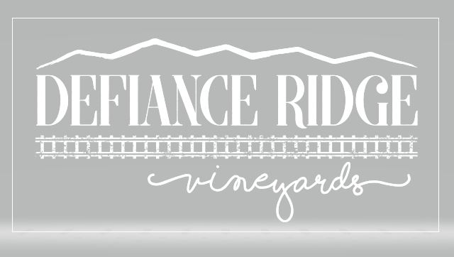

Defiance Ridge Vineyards Trivia Night Menu
served from 4pm – 8:30pm

Farmer's Board: $20.00
Local meats and cheeses, nuts, pickles, olives, coarse grain mustard, crusty bread.
Rustic Cheese Board: $18.00
Artisan cheeses, fruit, preserves, crusty bread
Sausage Board: $8.00
Grilled local sausage, maple bourbon bbq sauce, ale honey mustard sauce
Smoked Trout Board: $19.00
Half trout, red onion, capers, dill, aioli, toast
Chicken Wings: $8.00/6 wings
Toasted Ravioli w/marinara sauce: $6.00/8 pieces
Barnyard Burger w/side: $15.00
Brisket & prime rib blend, bacon, fried egg, white cheddar, caramelized onion, bibb lettuce, tomato, house mustard, roasted garlic aioli, pickle
Pulled Pork Sandwich w/side: $12.00
Veggie Wrap w/side: $10.00
Shredded carrots, cucumbers, mixed greens, tomato, sunflower seeds, white bean hummus, roasted tomato vinaigrette
Side of Chips: $3.00
Side of Fries: $4.00

